COMPLETABLE Future 2

Locks 3

Reentrant Lock in Java 4

**What are Reentrant Locks?** 4

**ReentrantLock Methods** 5

TRYLock 8

ReadWriteLock 9

FORKJOIN 11

WORK STEALING 13

**Using volatile vs AtomicInteger** 15

Atomic 15

LOCK’s CONDITION class 16

SEMAPHORES 17

**Phaser vs CountDownLatch vs CyclicBarrier** 20

CountDownLatch 21

CYCLIC BARRIER 21

PHASER 21

**Java Asynchronous Programming** 26

**CONCURRENCY BASICS** 28

1. wait, notify, notifyAll 28

wait() vs notify() vs notifyAll in threading 28

2. How to kill a thread 29

**ADVANCED JAVA** 29

1. Daemon Threads 29

2. ExecutorService 29

# COMPLETABLE Future



.submit is not blocking---JVM returns placeholder for future object, and can do other operations. But once .get() is called:

**Future.get() is blocking operation ---main thread will block..**

Example in above 4 steps are sequential.. main thread will wait for each operation-----problem



* (lambda expressions)Once getOrder successful, pass its ouput to next method enrich----and so on
* Doing flow for 100 orders
* No blocking, no future.get
* If secnd step used thenApplyAsync---then first operation will be done bu one thread(getOrder() ) , but second operation will be done by another thread. thenAlpply🡪operations by same thread.





If in another thrad,, overloaded methods.. Note---thenApplyAsync

This forloop will run 100 times immediately, but main thread will not work.



This acts as catch block in any of above 3 methods called getOrder,enrich,performPayment

* Internally it is based on ForkJoinPool

# Locks

*/**  
 * Every Java object has an intrinsic lock (or a monitor lock) associated with  
 * it.  
 *   
 * Every Java object can be used as a lock.  
 *   
 * Intrinsic Locks are mutually exclusive, so one only thread can 'hold' the  
 * lock at time when it's using the synchronization mechanism.  
 *   
 * The lock is freed when the synchronized method/block ends.  
 *   
 * Synchronize serializes access for what is locked and guarantee memory  
 * visibility for the changes that happened inside the synchronized scope to all  
 * threads.  
 *   
 * Intrinsic locks are reentrant: if you are holding it, you can acquire it  
 * again, without deadlocking.  
 */*

## Reentrant Lock in Java

**Background**

The traditional way to achieve thread synchronization in Java is by the use of [synchronized](https://www.geeksforgeeks.org/synchronized-in-java/) keyword. While it provides a certain basic synchronization, the synchronized keyword is quite rigid in its use. For example, a thread can take a lock only once. Synchronized blocks don’t offer any mechanism of a waiting queue and after the exit of one thread, any thread can take the lock. This could lead to starvation of resources for some other thread for a very long period of time.

**Reentrant Locks are provided in Java to provide synchronization with greater flexibility.**

### **What are Reentrant Locks?**

The ReentrantLock class implements the Lock interface and provides synchronization to methods while accessing shared resources. The code which manipulates the shared resource is surrounded by calls to lock and unlock method. This gives a lock to the current working thread and blocks all other threads which are trying to take a lock on the shared resource.

As the name says, ReentrantLock allow threads to enter into lock on a resource more than once. When the thread first enters into lock, a hold count is set to one. Before unlocking the thread can re-enter into lock again and every time hold count is incremented by one. For every unlock request, hold count is decremented by one and when hold count is 0, the resource is unlocked.

Reentrant Locks also offer a fairness parameter, by which the lock would abide by the order of the lock request i.e. after a thread unlocks the resource, the lock would go to the thread which has been waiting for the longest time. This fairness mode is set up by passing true to the constructor of the lock.

These locks are used in the following way:

filter_none

edit

play_arrow

brightness_4

|  |
| --- |
| public void some_method()  {          reentrantlock.lock();          try          {              //Do some work          }          catch(Exception e)          {              e.printStackTrace();          }          finally          {              reentrantlock.unlock();          }    } |

The unlock statement is always called in the finally block to ensure that the lock is released even if an exception is thrown in the method body(try block).

### **ReentrantLock Methods**

* **lock():** Call to the lock() method increments the hold count by 1 and gives the lock to the thread if the shared resource is initially free.
* **unlock():** Call to the unlock() method decrements the hold count by 1. When this count reaches zero, the resource is released.
* **tryLock():** If the resource is not held by any other thread, then call to tryLock() returns true and the hold count is incremented by one. If the resource is not free then the method returns false and the thread is not blocked but it exits.
* **tryLock(long timeout, TimeUnit unit):** As per the method, the thread waits for a certain time period as defined by arguments of the method to acquire the lock on the resource before exiting.
* **lockInterruptibly():** This method acquires the lock if the resource is free while allowing for the thread to be interrupted by some other thread while acquiring the resource. It means that if the current thread is waiting for lock but some other thread requests the lock, then the current thread will be interrupted and return immediately without acquiring lock.
* **getHoldCount():** This method returns the count of the number of locks held on the resource.
* **isHeldByCurrentThread():** This method returns true if the lock on the resource is held by the current thread.

**ReentrantLock Example**

In the following tutorial, we will look at a basic example of Reentrant Locks.

**Steps to be followed**

1. Create an object of ReentrantLock

2. Create a worker(Runnable Object) to execute and pass the lock to the object

3. Use the lock() method to acquire the lock on shared resource

4. After completing work, call unlock() method to release the lock

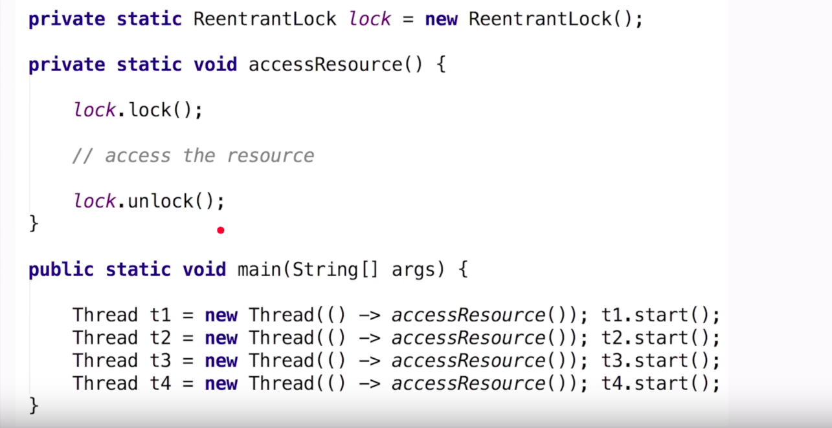

Same as synchronised block with more features

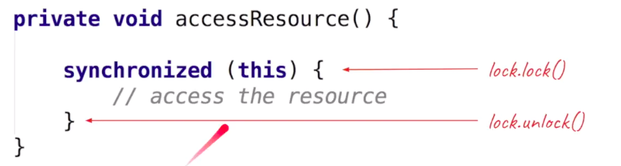

It is advisable to use unlock in tcatch block::: else if for one thread there is exception. Others will never get lock—will be in waiting states

Reentrant lock: lock can be called multiple times without calling unlock

But number of unlock and lock counts to match 

Suppose Thread T1 has alock, then it updated resource, and possible it calls same method **again (via recursion) ,**again makes a lock on which it already has a lock—hence reentrant lock … but behind the scenes since it is already owner of lock,, don’t lock again. Just increase lock count



Reentrant lock allows Boolean in contructor

True: fair lock

---so next thread waiting in ueue in FIFO manner(which waited most) will acquire next lock

By default locks are unfair (also can be made by passing Boolean as false) ---faster as it does not use queue—but it is possible that some of thread could wait a lot.



## TRYLock

If you want thread not to block if cant get lock (available with another)—will come to else state and do other job



Also time period available----example wait for 5 seconds if you can acquire lock –else do other stuffs



Even if Reentrant lock if Fair------TryLock does not honor the fairness

Workaround to use timeout with 0 seconds



## ReadWriteLock

If **t1 and t2** only want to read the seats available , and t3 abnd t4 are updating seats, so it is not good t1 block process and make other to wait







So for read lock---all threads will read resource at a time

But for write lock---only one thread will access resource at a time

Only one of read(n threads)/write(1) will be there.=, not both





# FORKJOIN

DIVIDE VERY LARGE task into various sub-tasks.. These sub-tasks could run parallelly in different CPU cores, and results of each could be aggregated later

Each subtasks can also create more subtasks. **But has to wait for sub-taks s to complete so that results could be joined**

2 operations involved:

1) forking: means splitting tasks into sub-tasks

2)joining results of each subtasks .

 

Each thread has its own queue (Deque—double ended queue)

When a task is divided into varios sub tasks, all subtasks are not stored in main queue , but in thread’s dequeue locally



Advatages of queue per thrrad:

1) as touching its own queue, not to worry of synchronisation

2)just keep picking tasks from own queue

3)

# WORK STEALING

Thread0 has completed its all sub-tasks, no sub-tasks present in its dequeue,

But Thread1 has still many sub-tasks (so t0 starts stealing some subtasks from dequeue from t1 **---but from back side,** as t1 is taking sub-tasks from front(FIFI), so helping to complete sub-tasks)







For ideal forkjoin (make sub-tasks independent of each other)



ForkJoin are Futureswith additional methods. So methods of futures applicable



# **Using volatile vs AtomicInteger**

Volatile used to solve visibility problems



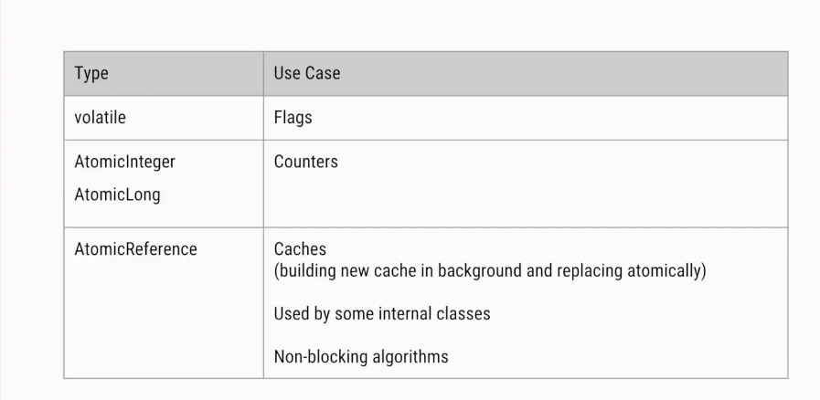

## Atomic

# LOCK’s CONDITION class





Condition.signal(will wake first thread waiting for longest time) --fairness

To handle spurious wake ---use while loop,, theat is possible this thread was wairitng longest, and some thread signalled it to wake, but since in while loop, it waill again come to wait

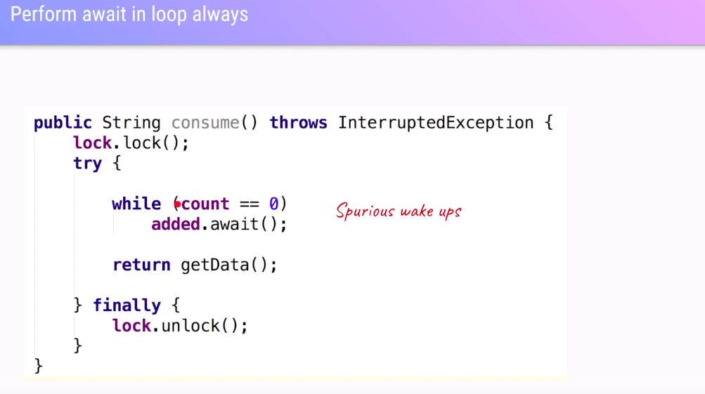

Producer –consumer



# SEMAPHORES

Suppose 50 thrads, only 3 threads allowed at a time concurrently



As only 3 allowed, so 4th is blocked



Once T1 is done processing, it will call release method---to tell I am done processing, release its permit





If you don’t want to handle exception, acquireUninterrptibly



A thread can take multiple permits: but remember if multiple permitted, release same number of permits





# **Phaser vs CountDownLatch vs CyclicBarrier**

Main thread waits till all 3 dependent services tasks completed

## CountDownLatch



## CYCLIC BARRIER

All threads wait till all threads have reached barrier.await(), and only then process continuessince cyclic, same barrier can repeated ,



## PHASER

--can act as cyclicLatch

--can act as cyclic barrier

-- plus more flexibility –like deregistering any point of time











Here phaser has 7 parties registered

Deregister:: it will not participate anymore in next cycles of this paheser





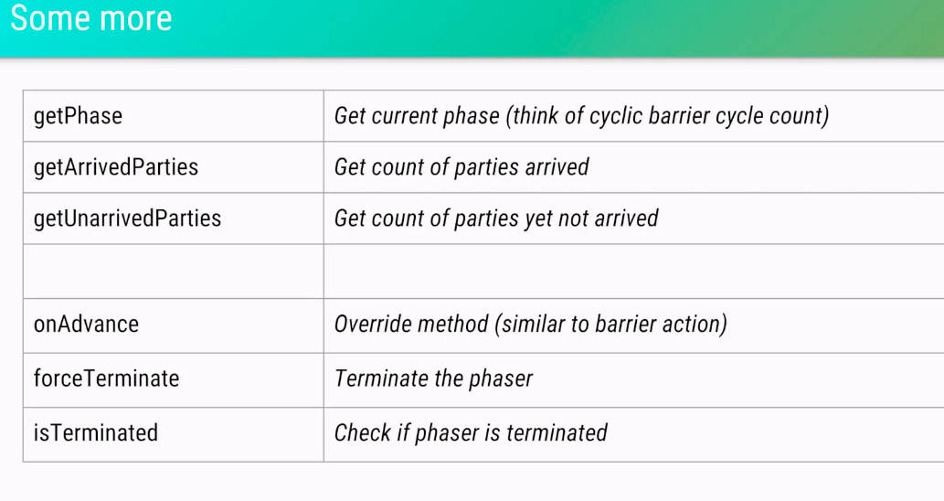

# **Java Asynchronous Programming**



Here main thread will not stop









Mono is like callback ---will return object when ready,, but not block

# **CONCURRENCY BASICS**

## 1. wait, notify, notifyAll

## wait() vs notify() vs notifyAll in threading

Let's see some key points about these fundamental methods in Java especially from multi-threading and concurrency perspective.  
  
1) Though wait, notify and notifyAll are related to threads they are not defined in java.lang.Thread class, instead they are **defined in the Object class.**   
  
2) You must call the wait(), notify() and notifyAll() **methods from a synchronized context** in Java i.e. inside [synchronized method](http://javarevisited.blogspot.com/2011/04/synchronization-in-java-synchronized.html) or a [synchronized block](http://java67.blogspot.com/2013/01/difference-between-synchronized-block-vs-method-java-example.html). **The thread must hold the lock on th**e object it is going to call the wait() or notify() method and that is acquired when it enter into a synchronized context.  
  
If you call it without holding a lock then they will throw **IllegalMonitorStateException** in Java.   
  
3) You must call **wait() method from inside a loop, don't** call with an if block because a thread can sporadically awake from the wait state without being notified by another party.

**synchronized** (theSharedObject) {

**while** (condition) {

theSharedObject**.**wait();

}

*// do something*

}

4) When a thread calls the wait() method in Java, it goes to the wait state by **releasing the lock**, which is later acquired by the other thread who can notify this thread. Here is a nice diagram of how state transition of a thread happens in Java:

5) A thread waiting due to a call to wait() method can wake up either by notification e.g. calling [notify() or notifyAll()](http://java67.blogspot.com/2013/03/difference-between-wait-vs-notify-vs-notifyAll-java-thread.html) method on the same object or due to interruption.  
6) The wait() method throws InterrruptedException in Java, which is a **checked exception.** You must provide a handler for this, but it's your choice whether you really want to handle the interruption or not.  
  
7) You must call wait() **method on shared object** e.g. in[producer-consumer problem](http://javarevisited.blogspot.com/2015/06/java-lock-and-condition-example-producer-consumer.html), the task queue is shared between producer and the consumer thread. In order to communicate, you must use that queue on synchronized block and subsequently called wait() method on queue e.g. queue.wait().  
  
The other thread should also call the notify() or notifyAll() method on same shared object i.e. queue.notify() or queue.notifyAll().  
  
8) When you call the[notify() method](http://javarevisited.blogspot.com/2012/10/difference-between-notify-and-notifyall-java-example.html) on a shared object and if more than one thread is waiting on that **lock then anyone of them will get the notification**, which thread will get the notification is not guaranteed. If only one thread is waiting then it will get the notification.  
When you call the notifyAll() method **on shared object** and if more than one thread is waiting for notification **then all of them will receive the notification but** **who will get the CPU to start execution is not guaranteed**. It depends on upon [thread scheduler](http://javarevisited.blogspot.com/2011/07/java-multi-threading-interview.html).

Main difference between notify() and notifyAll() is that in case of notify() only one of the waiting thread gets a notification but in case of notifyAll() all thread get notification.

## 2. How to kill a thread

--not that simple since the ***Thread.stop()*** method is deprecated

# **ADVANCED JAVA**

## 1. Daemon Threads

## 2. ExecutorService

ExecutorService executor = Executors.newFixedThreadPool(10); *//create a thread-pool with 10 threads:*